Facilitator Bios

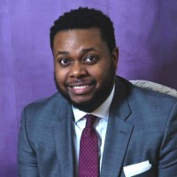
James Bell III (he/him), Equity Strategist, Founder, CEO, Just Solutions, LLC
James is a doctoral candidate at the University of Southern California Suzanne Dworak-Peck School of Social Work studying social innovation and racial health inequities, with an anticipated graduation in May 2021. James has nearly a decade of experience in building relationships/creating partnerships between diverse stakeholders around critical issues and a strong background in assembling and managing diverse teams to meet client needs. James is an affiliate of Event Garde.

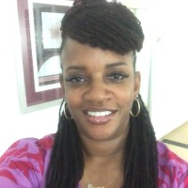
Denise Evans (she/her), CEO, Consult Me, LLC
Denise is a skilled facilitator and trainer, trained in the Technology of Participation methods, who specializes in implicit bias, cultural intelligence, and health disparities and inequities. Denise has experience working in the non-profit sector on issues of equity and social justice. She is an affiliate facilitator with Event Garde. Denise is an affiliate of Event Garde.

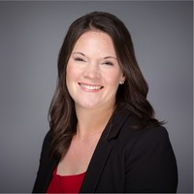
Lindsay Gross (she/her), Director, Facilitation Services, Event Garde
Lindsay is a certified meeting facilitator with expertise in working with multidisciplinary groups, assisting them with goal setting, implementation support, and creating an engaging environment that allows for consensus building. She has worked with professionals from both the public and private sectors to help them conduct complex needs assessments, visioning, action planning and implementation.

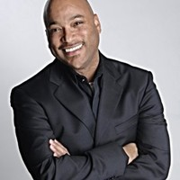
Robert Quintana Hopkins (he/him), Director of Organizational Development, Stanford University/CEO, Circles of Change, LLC
Robert is an organizational development consultant with over 20 years of experience serving as an external change consultant and facilitator, as well as an internal HR leader. Robert is currently completing a PhD in organizational psychology at the California School of Professional Society. Robert is an affiliate of Event Garde.

Krista Rowe (she/her), Director, Diversity, Equity & Inclusion, Event Garde
Krista is a certified facilitator with extensive experience in facilitating, training and providing technical assistance to local, state and national non-profit, government and private sector organizations in Diversity, Equity and Inclusion (DEI). She is known for taking great care and patience with participants when assisting organizations in establishing a baseline of understanding, developing methods for systems change and establishing practical skills for equitable practice. Krista is a graduate of Michigan State University and holds a bachelor’s degree in Community Advocacy and Governance with a concentration in Political Science.

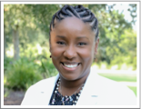
Stephani Tyrance (she/her) CEO for Brown Brown & Tyrance, LLC
Stephani is a public health professional trained in ToP facilitation and Racial Healing Circles. In her free time Stephani teaches childbirth and breastfeeding education and serves her community through various organizations. She is a member of Delta Sigma Theta Sorority, Incorporated and the National Coalition of 100 Black Women, Incorporated. Stephani is willing to participate in difficult conversations and is equally committed to engage generously with love and patience. Stepahni is an affiliate of Event Garde.

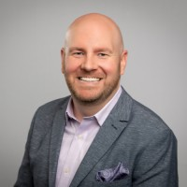
Aaron Wolowiec (he/him/his), CEO, Event Garde
Aaron is a learning/meetings strategist, certified Technology of Participation facilitator, and association author, coach, and speaker. He designs engaging, multisensory learning experiences for association learners, resulting in acquisition of new knowledge and skills, forging of new relationships, and applied learning and perspective in the workplace. As the Chief Executive Officer of Event Garde, Aaron is a serial learner and entrepreneur who is nationally recognized for his professional development and facilitation work with boards, learners, staff, and volunteers.

