Theory of Change:

Event Garde uses the Circles of Change model of organizational change, created by Robert Quintana Hopkins (he/him), Director of Organizational Development, Stanford University/CEO, Circles of Change, LLC.

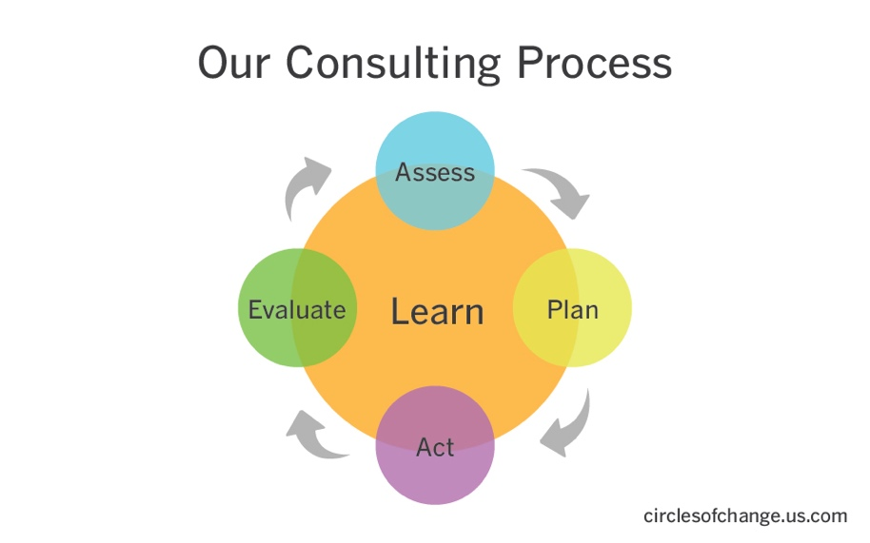

Assess - gather internal and external data to identify trends, strengths, opportunities and gaps.

Plan - develop a long-term strategic plan, and/or create a concrete short-term action plan.

Act - implement the plan and ensure key stakeholders have the appropriate level of ownership.

Evaluate - measure outcomes and impact based on pre-established targets and success indicators.

Learn - observe, reflect, interpret and adapt throughout the continuous process of change.

